**Project Report Format**

1. **INTRODUCTION**

The fuel efficiency of heavy-duty trucks can be beneficial not only for the automotive and transportation industry but also for a country’s economy and the global environment. The cost of fuel consumed contributes to approximately 30% of a heavy-duty truck’s life cycle cost. Reduction in fuel consumption by just a few percent can significantly reduce costs for the transportation industry. The fuel economy of heavy-duty vehicles (HDV) is affected by several real-world parameters like road parameters, driver behavior, weather conditions, and vehicle parameters, etc.  The model was further evaluated with data collected from a vehicle on-road trip .A simulation model was developed based on engine capacity, fuel injection, fuel specification, aerodynamic drag, grade resistance, rolling resistance, and atmospheric conditions, with simulated dynamic driving conditions to predict fuel consumption.

Machine learning techniques such as support vector machine (SVM) , random forest (RF) , and artificial neural networks (ANN) are widely applied to turn data into meaningful insights and solve complex problems .While the current approaches determine the fuel consumption of the vehicle, combining these techniques with data helps to identify parameters that may cause anomalies, such as malfunctions due to wear and tear of the engine, improper maintenance, engine failure, exhaust after-treatment system, and external factors like climate, traffic, road conditions, etc .

Several previous models for both instantaneous and average fuel consumption have been proposed. Physics-based models are best suited for predicting instantaneous fuel consumption because they can capture the dynamics of the behavior of the system at different time steps. Most states have now mandated that truck fleets update their vehicle inventory with modern vehicles due to air quality regulations. These techniques have been applied to estimate emissions and fuel consumption in motor vehicles, trucks, ships , and aircraft . A statistical model which is fast and simple compared to the physical load-based approach was developed to predict vehicle emissions and fuel consumption.  However, these models are able to identify and learn trends in average fuel consumption with an adequate level of accuracy.

* 1. **Project Overview**

In the paper, we are enhancing the accuracy of the fuel consumption prediction model with Machine Learning to minimize Fuel Consumption. This will lead to an economic improvement for the business and satisfy the domain needs. We propose a machine learning model to predict vehicle fuel consumption. The proposed model is based on the Support Vector Machine algorithm. The Fuel Consumption estimation is given as a function of Mass Air Flow, Vehicle Speed, Revolutions Per Minute, and Throttle Position Sensor features. The proposed model is applied and tested on a vehicle’s On-Board Diagnostics Dataset. These types of fleets exist in various sectors including, road transportation of goods, public transportation , construction trucks and refuse trucks .

The observations were conducted on 18 features. Results achieved a higher accuracy with an R-Squared metric value of 0.97 than other related work using the same Support Vector Machine regression algorithm. We concluded that the Support Vector Machine has a great effect when used for fuel consumption prediction purposes. Data modeling can easily help to diagnose the reason behind fuel consumption with a knowledge of input parameters. Our model can compete with other machine learning algorithms for the same purpose which will help manufacturers find more choices for successful Fuel Consumption prediction models

Engines and Emissions (WVU CAFEE) using the portable emissions monitoring system (PEMS). The performance of the artificial neural network was evaluated using mean absolute error (MAE) and root mean square error (RMSE). The model was further evaluated with data collected from a vehicle on-road trip. The study shows that artificial neural networks performed slightly better than other machine learning techniques such as linear regression (LR), and random forest (RF), with high R-squared (R2) and lower root mean square error.

**1.2. Purpose**

Fuel economy is a measure of how far a vehicle will travel with a gallon of fuel; it is expressed in miles per gallon. This is a popular measure used for a long time by consumers in the United States; it is used also by vehicle manufacturers and regulators, mostly to communicate with the public. As a metric, fuel economy actually measures distance traveled per unit of fuel. Before proceeding, it is necessary to define the terms fuel economy and fuel consumption; these two terms are widely used, but very often interchangeably and incorrectly, which can generate confusion and incorrect interpretations .Fuel consumption is the inverse of fuel economy. It is the amount of fuel consumed in driving a given distance. It is measured in the United States in gallons per 100 miles, and in liters per 100 kilometers in Europe and elsewhere throughout the world.

Fuel consumption is a fundamental engineering measure that is directly related to fuel consumed per 100 miles and is useful because it can be employed as a direct measure of volumetric fuel savings. It is actually as a fuel consumption. Because fuel economy and fuel consumption are reciprocal, each of the two metrics can be computed in a straight-forward manner if the other is known. In mathematical terms, if fuel economy is X and fuel consumption is Y, their relationship is expressed by XY = 1. This relationship is not linear, as illustrated by in which fuel consumption is shown in units of gallons per 100 miles, and fuel economy is shown in units of miles per gallon.

Also shown in the figure is the decreasing influence on fuel savings that accompanies increasing the fuel economy of high-mpg vehicles. Each bar represents an increase of fuel economy by 100 percent or the corresponding decrease in fuel consumption by 50 percent. The data on the graph show the resulting decrease in fuel consumption per 100 miles and the total fuel saved in driving 10,000 miles .The dramatic decrease in the impact of increasing miles per gallon by 100 percent for a high-mpg vehicle is most visible in the case of increasing the miles per gallon rating from 40 mpg to 80 mpg, where the total fuel saved in driving 10,000 miles is only 125 gallons, compared to 500 gallons for a change from 10 mpg to 20 mpg. Likewise, it is instructive to compare the same absolute value of fuel economy changes—for example, 10-20 mpg and 40-50 mpg.

**2. LITERATURE SURVEY**

**2.1. Existing Problem**

Fuel is one of a fleet operator’s biggest pain points. Being the second largest expense category (after labor costs), fuel seems to be an ever flowing source of stress and lost money. And if you don’t control it the fuel management is not a complex topic to dive into, if you’re already using a fleet management solution. This article will help you discover what other opportunities your software has in terms of fuel efficiency. And if you’re only considering getting or building an FMS, this will be your guide to the best features to ask your vendor about. A fuel management system is a subdivision of a fleet management system that uses telematics-based tools and analytical software to capture fuel consumption data and improve fuel economy.

Starting with the most extreme case that a car could be suffering through is a faulty engine. A damaged engine cannot work properly and in turn, can consume more fuel. Now you might be thinking that the engine itself can’t be faulty when the car has run only a few km. You are right. The engine may be fine but the crucial components that contribute to the combustion cycle could be faulty. For instance, a faulty spark plug or O2 sensor in a petrol engine and a dirty fuel injector in a diesel engine can cause more consumption of fuel resulting in low fuel mileage. Your engine may function normally for a while but the fuel won’t be burnt efficiently. This will eventually cause your car to consume more fuel than usual. They incorporate data about fuel transactions into analytics and learn what brands of fuel bring better economy, compare fuel usage across vehicles, break down fuel spend, and generally improve your fuel buying behavior.

Capture and prevent fuel theft and leakage. Fuel monitoring and anti-siphoning devices can update you on fuel amounts in trucks and on-site tanks and send alerts about fuel levels. Calculate and report fuel taxes. Integrated with your vehicle’s GPS, a fuel management system can automatically calculate traveled distance and purchased fuel to help file your IFTA tax reports. The ultimate benefit of fuel management systems is automation — operations that used to be done manually in spreadsheets can happen automatically in the background, providing analytics for you to base your decisions on. Now, let’s cover the main opportunities and how they work.

**2.2. References**

1. Anderson S.T; Fischer C.; Parry I.; Sallee J; Automobile Fuel Economy Standards: Impacts, Efficiency, and Alternatives. Rev. Environ.Econ.Policy2011,5.89–108.

2. Wang, J.; Rakha H.A. Fuel consumption model for conventional diesel buses. Appl. Energy 2016,170, 394–402.

3. Hellstrom E; Ivarsson M; Aslund, J.; Nielsen, L. Look-ahead control for heavy trucks to minimize trip time and fuel consumption. Control Eng. Pract .2009,17, 245–254.

4. U.S Environmental Protection Agency. Greenhouse Gas Emissions and Fuel Efficiency Standards for Medium-and Heavy-Duty Engines and Vehicles-Phase 2; Regulatory Impact Analysis EPA-420-R-16-900; Office of Transportation and Air Quality: AnnArbor, MI, USA, 2016.

5. U.S. Environmental Protection Agency. Greenhouse Gas Emissions and Fuel Efficiency Standards for Medium- and Heavy-Duty Engines and Vehicles-Phase 2; Regulatory Impact Analysis EPA-420-R-16-900; Office of Transportation and Air Quality: Ann Arbor, MI, USA, 2016.

**2.3. Problem Statement Definition**

Reduction in fuel consumption by just a few percent can significantly reduce costs for the transportation industry. The effective and accurate estimation of fuel consumption (fuel consumed in L/km) can help to analyze emissions as well as prevent fuel-related fraud. While going for a long trip, it is quit tough to analyze the need fuel consumption.

**3. IDEATION & PROPOSED SOLUTION**

**3.1. Empathy Map Canvas**

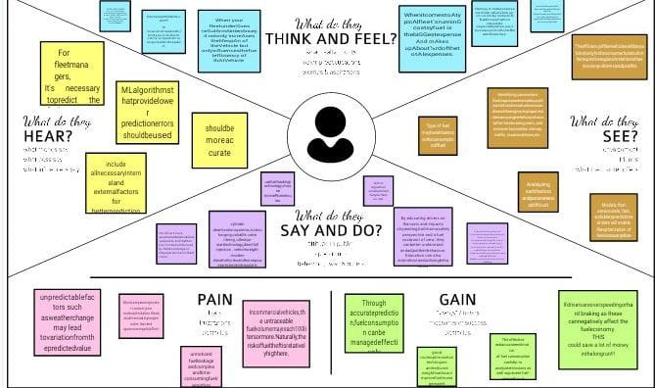

**3.2. Ideation & Brainstorming**

**Step-1:** Team Gathering, Collaboration and Select the Problem Statement

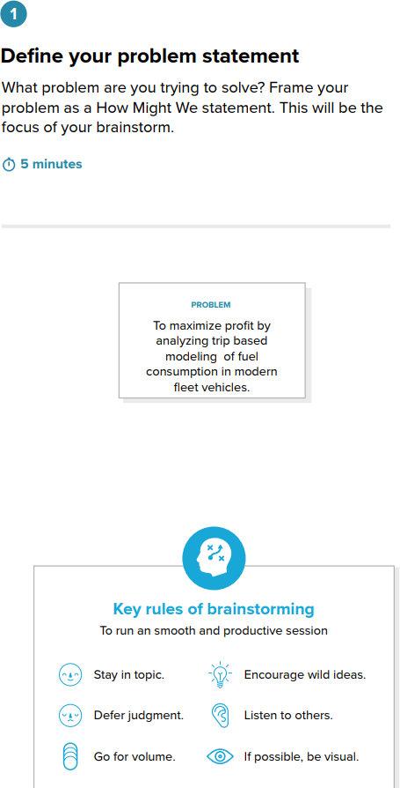



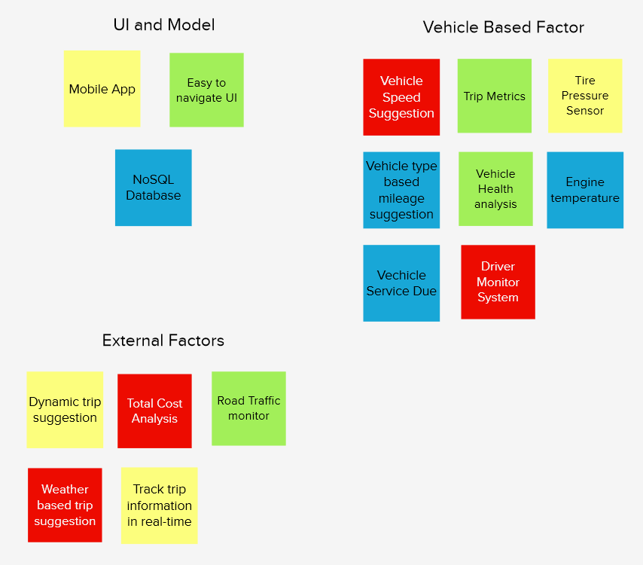**Step-2:** Brainstorm, Idea Listing and Grouping

**Step-3:** Idea Prioritization

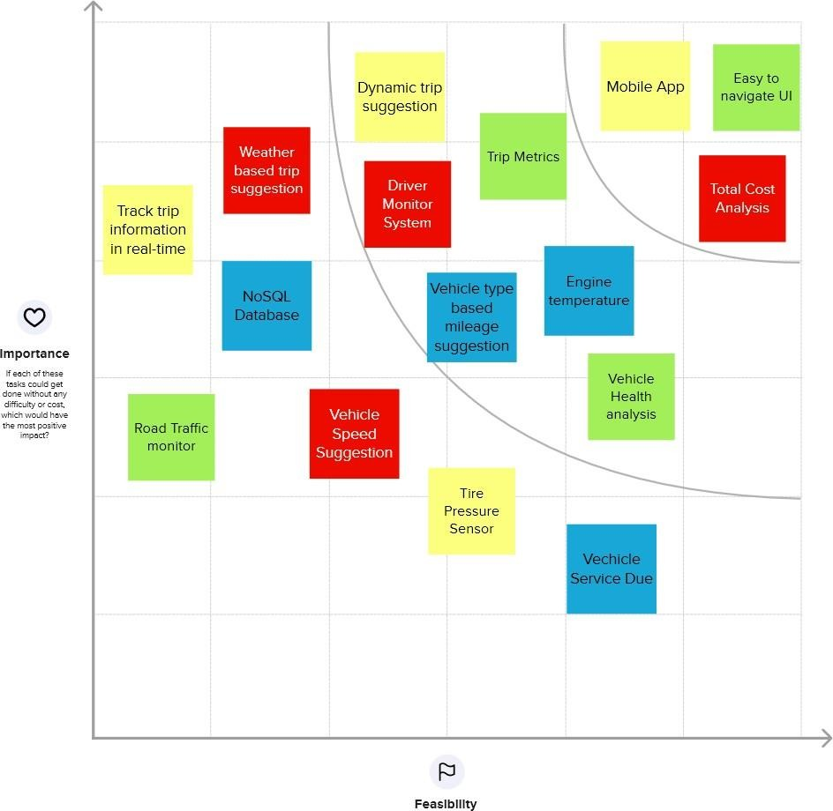

**3.3. Proposed Solution**

A more detailed description of the Offeror’s understanding of the TORFP scope of work, proposed methodology and solution. Even though we are aware that engines need fuel to run, that does not mean you can’t make some small changes to help you gain some fuel savings. Keep tires pumped up tires that are underinflated have a higher rolling resistance on the road. This means that with every kilometer traveled, your tires generate more friction and rolling resistance, and hence, will increase fuel consumption. If all your tires are underinflated by 10 psi, this could reduce fuel efficiency by up to 10%.Lose the weight in your boot.

For those with a habit of keeping everything and anything in the boot, in addition to emergency spares, think twice when loading up next time. Every extra 50kg your car puts on increases fuel consumption by 2%.Driving with the windows down at speeds faster than 80km/h causes a lot of wind resistance, and costs you a lot more fuel. Contrary to what you may think, in this situation, it’s simply more fuel efficient to drive with the air on. When cruising down a highway, your engine works hard to overcome wind resistance. You’ll burn up to 15% more fuel at 100 km/h and 25% more at 110 km/h.

That might tempt you to drive slow, but if you drive slower than 50 km/h, your engine would drop to a lower gear, thus using up more fuel. In conclusion, a steady 50 – 90 km/h on the highway is best to achieve optimal fuel economy. Slamming on the brakes increases fuel consumption as you need to accelerate again later. This is especially true if you follow too closely behind the vehicle in front of you. Not to mention, tailgating is dangerous and something to avoid. If you’re driving an automatic car, make use of cruise control to keep your speed constant. And if you’re driving a manual car, maintain a higher gear when appropriate. In each of these instances, your engines go through less revolutions per minute (RPM) and will reduce your fuel consumption.

**3.4.** **Problem Solution Fit**

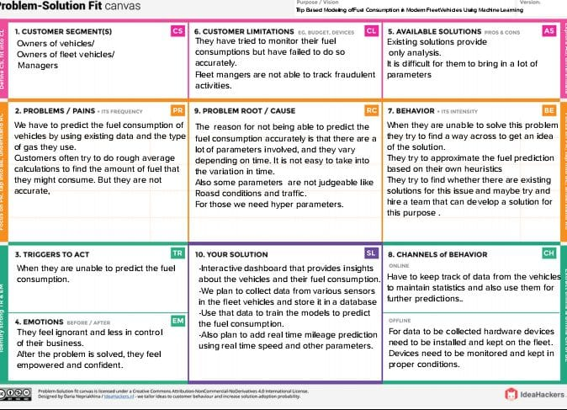

**4. REQUIREMENT ANALYSIS**

**4.1. Functional Requirement**

Following are the functional requirements of the proposed solution.

|  |  |  |
| --- | --- | --- |
| **FR No.** | **Functional Requirement (Epic)** | **Sub Requirement (Story/Sub-Task)** |
| FR-1 | User Registration/Login | Via Email  Via Phone number |
| FR-2 | User Dashboard | Single Sample Prediction  Multiple Sample Prediction  View user history |
| FR-3 | Output Generation | Visual Representation Report Generation |

**4.2. Non-Functional Requirements**

Following are the non-functional requirements of the proposed solution.

|  |  |  |
| --- | --- | --- |
| **FR No.** | **Non-Functional Requirement** | **Description** |
| NFR-1 | **Usability** | A user-friendly interface that makes processing easier for the user  Predictions are visually represented by the model. |
| NFR-2 | **Security** | User authentication: To have secured access, the user might have a private dashboard. |
| NFR-3 | **Reliability** | The model is capable should be able to handle massive amounts of data and run several samples at once. |
| NFR-4 | **Performance** | The model's accuracy is good because it combines several ML methods. |
| NFR-5 | **Availability** | The website is portable and responsive to mobile devices. To run on any device, only the most minimal configurations are needed. |

**5. PROJECT DESIGN**

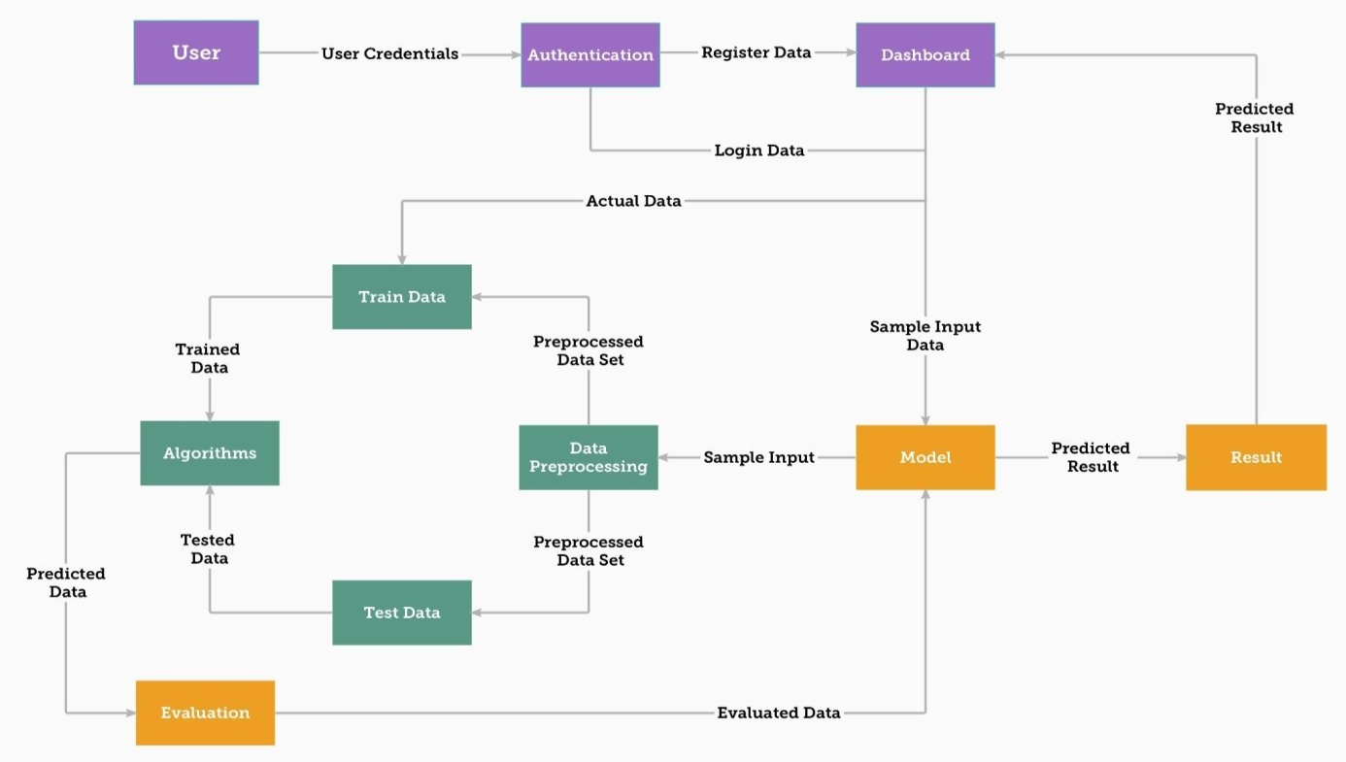**5.1. Data Flow Diagrams**

**5.2. Solution & Technical Architecture**

**Table-1: Components & Technologies:**

|  |  |  |  |
| --- | --- | --- | --- |
| **S. No** | **Component** | **Description** | **Technology** |
| 1. | Website | To predict fuel use, user interacts with prediction model via website. | HTML,CSS, Java Script, Bootstrap |
| 2. | Cloud Database | The model receives information from an IBM cloud database. | IBM Cloud DB, ibm_db (python package) |
| 3. | API | used to expand service to additional applications | Flask Application |
| 4. | JWT &Sessions | It is employed to manage JSON web tokens (signing, verifying, decoding) | PyJWT, Flask-Sessions |
| 5. | Machine Learning Model | This model was created using ML algorithms to forecast fuel use. | Sklearn, Algorithms- MLR |
| 6. | Data processing | Data is pre-processed and used for training the model which is subsequently used for prediction. | Pandas, NumPy, Matplotlib |

**5.3. User Stories**

|  |  |  |  |  |  |  |
| --- | --- | --- | --- | --- | --- | --- |
| **User Type** | **functional**  **Requirement (Epic)** | **User**  **Story Number** | **User St**o**ry/Task** | **Acceptance**  **criteria** | **Priority** | **Release** |
| Customer | Registration/ Login | USN-1 | I can sign up or log in as a user to establish a dashboard for my processes. | I can access my dashboard or account. | High | Sprint-3 |
|  | Dashboard | USN-2 | I can enter values for a single sample prediction once I've accessed the dashboard. | I can forecast using just one sample. | High | Sprint-1 |
| Customer (Organization) |  | USN-3 | I can insert data via an Excel sheet for several sample predictions once I've accessed the dashboard. | Multiple sample predictions can be made by me. | Medium | Sprint-2 |
|  |  | USN-4 | I can see a visual representation of the prediction as a user. | I can produce in a variety of ways. | High | Sprint-1 |
|  |  | USN-5 | I can see a visual representation of the prediction as a user. | I have access to information about my procedure and forecast. | Medium | Sprint-1 |
|  | Documentation | USN-6 | I can consult the documentation as a user for assistance and direction | I can go to the user handbook for advice. | Medium | Sprint-1,2, 3,4 |
| Developer | Settings | USN-7 | I can view the API token and access the dashboard's settings as a developer. | I can see the API token I created when I made requests to forecast, download reports, etc. | Low | Sprint-4 |
|  |  | USN-8 | I can send requests to servers using the API token as a developer. | I can submit a request to the server with a token. | Medium |  |

**6. PROJECT PLANNING & SCHEDULING**

**6.1. Sprint Planning & Estimation**

|  |  |  |  |  |  |  |
| --- | --- | --- | --- | --- | --- | --- |
| **Sprint** | **Total Story Points** | **Duration** | **Sprint Start Date** | **Sprint End Date(Planned)** | **Story Points Completed (as on Planned End Date)** | **Sprint Release Date (Actual)** |
| Sprint-1 | 8 | 6 Days | 24 Oct 2022 | 17 Nov 2022 | 17 Nov 2022 | 11Nov 2022 |
| Sprint-2 | 10 | 6 Days | 31 Oct 2022 | 17 Nov 2022 | 17 Nov 2022 | 10 Nov 2022 |
| Sprint-3 | 13 | 6 Days | 07 Nov 2022 | 17 Nov 2022 | 17 Nov 2022 | 29 Oct 2022 |
| Sprint-4 | 13 | 6 Days | 07 Nov 2022 | 17 Nov 2022 | 17 Nov 2022 | 28 Oct 2022 |

**6.2. Sprint Delivery Schedule**

|  |  |  |  |  |  |
| --- | --- | --- | --- | --- | --- |
| **Sprint** | **Functional**  **Requirement (Epic)** | **User Story Number** | **User Story/Task** | **Priority** | **Team Members** |
| Sprint-1 | Registration | USN-1 | I can sign up as a user with my email and password. | High | Likkith K.S |
| Sprint-2 |  | USN-2 | I may sign up as a user using my Gmail account. | Medium | Poorna G |
| Sprint-1 |  | USN-3 | When I register for the application as a user, I will get a confirmation email. | Low | Premila Gandhi G |
| Login | USN-4 | I may access my dashboard as a user by entering my  email address and password. | High | Boomavathi V |
| Dashboard | USN-5 | My account information is available on the dashboard. | Low | Likkith K.S |
| Sprint-2 | Prediction Model | USN - 6 | I can enter values for a single sample prediction once I've accessed the dashboard. | High | Premila Gandhi G |

|  |  |  |  |  |  |
| --- | --- | --- | --- | --- | --- |
| Sprint-3 |  | USN-7 | I can perform predictions by entering data into an  Excel sheet for several sample predictions according to the template. | Medium | Boomavathi V |
|  | USN - 8 | I can see a visual representation of the prediction as a user. | Medium | Poorna G |
| Report Generation | USN - 9 | I can view a thorough report of my forecast as a user. | High | Boomavathi V |
| Sprint-4 | Rest API | USN-10 | I can use an API Token as a developer to submit requests to the server. | Low | Premila Gandhi G |
| Documentation | USN-11 | I can use the documentation and user manual as a user for assistance and direction. | High | Poorna G |
|  | USN-12 | I can consult technical documentation as a developer to comprehend the application flow. | Medium | Likkith K.S |

**6.3. Reports from JIRA**

|  |  |  |  |  |  |  |
| --- | --- | --- | --- | --- | --- | --- |
| **Sprint** | **Total Story Points** | **Duration** | **Sprint Start Date** | **Sprint End Date(Planned)** | **Story Points Completed (as on Planned End Date)** | **Sprint Release Date (Actual)** |
| Sprint-1 | 8 | 6 Days | 24 Oct 2022 | 17 Nov 2022 | 17 Nov 2022 | 16 Nov 2022 |
| Sprint-2 | 10 | 6 Days | 31 Oct 2022 | 17 Nov 2022 | 17 Nov 2022 | 17 Nov 2022 |
| Sprint-3 | 13 | 6 Days | 07 Nov 2022 | 17 Nov 2022 | 17 Nov 2022 | 16 Nov 2022 |
| Sprint-4 | 13 | 6 Days | 07 Nov 2022 | 17 Nov 2022 | 17 Nov 2022 | 17 Nov 2022 |

**Velocity:** Imagine we have a10-days print duration, and the velocity of the team is 20(pointspersprint).Let’s calculate the team’s average velocity(AV) per iteration unit (story points per day)

**AV=Velocity/Sprint duration**

|  |  |
| --- | --- |
| Sprint | Average Velocity |
| Sprint1 | 1.33 |
| Sprint2 | 1.67 |
| Sprint3 | 2.17 |
| Sprint4 | 2.17 |

**Total Average Velocity = 1.83**

**Burn chart:**

A burn down chart is a graphical representation of work left to do versus time. It is often used in agile software development methodologies such as Scrum. However, burn down charts can be applied to any project containing measurable progress over time.

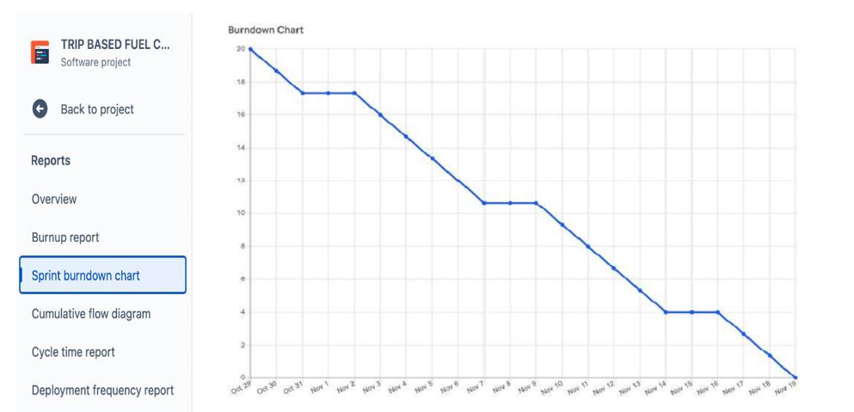

**7. CODING & SOLUTIONING**

**7.1. Feature 1**

Have done building a web application that is integrated to the model we built. A UI is provided for the uses where user has to enter the values for predictions. The enter values are given to the saved model and prediction is showcased on the UI.

**Building HTML Pages:**

<!DOCTYPE html>

<html>

<head>

<title>Fuel Consumption Prediction using machine learning</title>

//<link rel="stylesheet" type="text/css" href="w">

<style>

  * {

    box-sizing: border-box;

  }

  body {

    font-family: 'Montserrat';

  }

  .header {

    top: 0;

    margin: 0px;

    left: 0px;

    right: 0px;

    position: fixed;

    background-color: black;

    color: whites;

    box-shadow: 0px 8px 4px lightgrey;

    overflow: hidden;

    padding-top: 15px;

    font-size: 2vw;

    width: 100%;

    text-align: left;

    padding-left: 100px;

    opacity:0.9;

  }

  .header_text{

    font-size: 2vw;

    text-align: center;

  }

  .content{

    margin-top: 100px;

  }

  .text{

    font-size:20px;

    margin-top:10px;

    text-align:center;

  }

  input[type=number], select{

    width:50%;

    padding: 12px 20px;

    margin: 8px 0;

    display: inline-block;

    border: 1px solid #ccc;

    border-radius: 4px;

    box-sizing: border-box;

  }

  input[type=submit] {

    width: 50%;

    background-color: #000000;

    color: white;

    padding: 14px 20px;

    margin: 8px 0;

    border: none;

    border-radius: 4px;

    cursor: pointer;

  }

  input[type=submit]: hover{

    background-color: #5d6568;

    color: #ffffff;

    border-color: black;

  }

  form{

    margin-top: 20px;

  }

  .result{

    color: black;

    margin-top:30px;

    margin-bottom: 20px;

    font-size: 25px

    color: red;

  }

</style>

</head>

<body align = center>

  <div class="header">

          <div>Fuel Consumption Prediction</div>

  </div>

  <div class = "content">

  <div class="header_text">Fuel Consumption Prediction</div>

  <div class= "text">Fill in and below details to predict the consumption on the gas type.</div>

  <form action="{{url_for('predict')}}" method="POST">

    <input type="number" step="any" id="distance" name="distance" placeholder="distance(km)" ><br>

    <input type="number" id="speed" name="speed" placeholder="speed(km/hr)"><br><br>

    <input type="number" id="tem_outside" name="tem_outside" placeholder="temp_outside(°C)"><br>

    <input type="number" id="gas_type" name="gas_type" placeholder="gas_type"><br><br>

    <input type="number" id="rain" name="rain" placeholder="rain"><br>

    <input type="number" id="sun" name="sun" placeholder="sun"><br><br>

    <input type="submit" value="Submit">

  </form>

</body>

</html>

**8. TESTING**

**8.1. Test Cases**

The below mention chart conveys the user test cases and its details of the test cases

|  |  |  |  |  |
| --- | --- | --- | --- | --- |
| Steps To Execute | Test Data | Expected Result | Actual Result | Status |
| 1)Run the Fuel Consumption Prediction page | <http://127.0.0.1:5000> | Local hosted the Web app Successfully | Working as expected | Pass |
| 2)Enter the values to be predicted | Enter the values of distance, Speed, Temp_out, Gas type, rain and sun | Predicted Successfully | Working as expected | Pass |
| 3)Predicted value displaying(output) | Value of fuel consumption litre (output) | The value Fuel consumption came Successfully | Working as expected | Pass |

**8.2.User Acceptance Testing**

This report shows the number of resolved or closed bugs at each severity level, and how

they were resolved. The following are the detail and description for user acceptance testing.

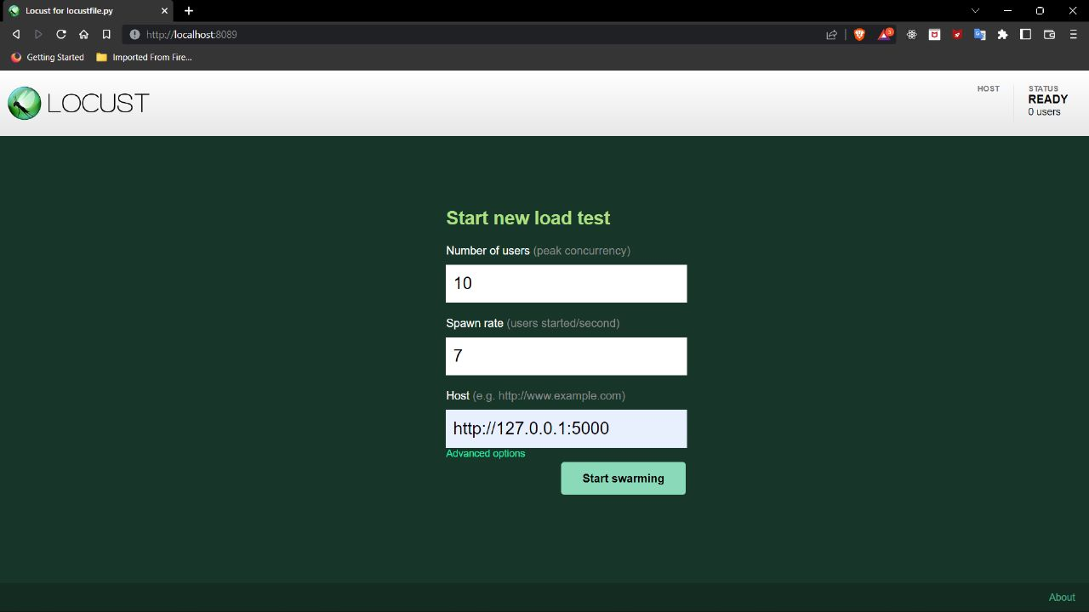

**Satatistics**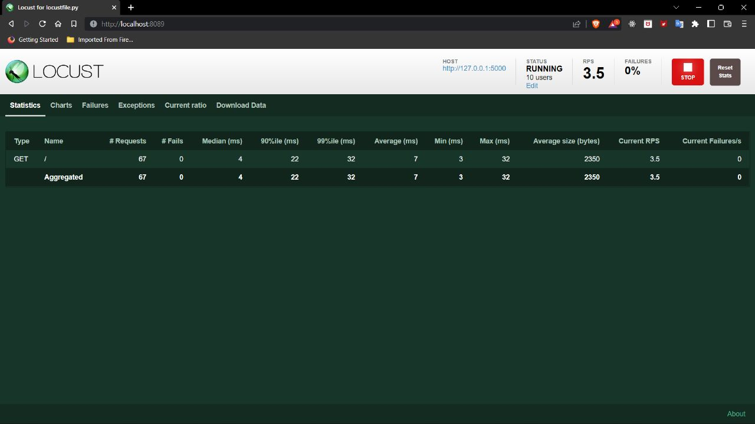

**Current ratio:**

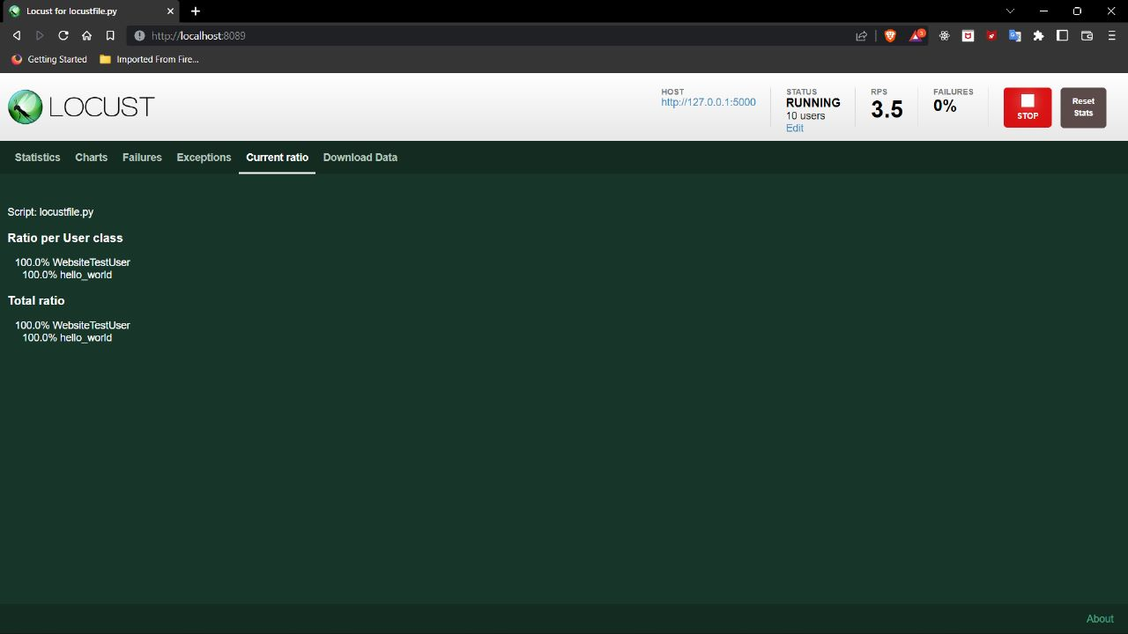

**Chart:**

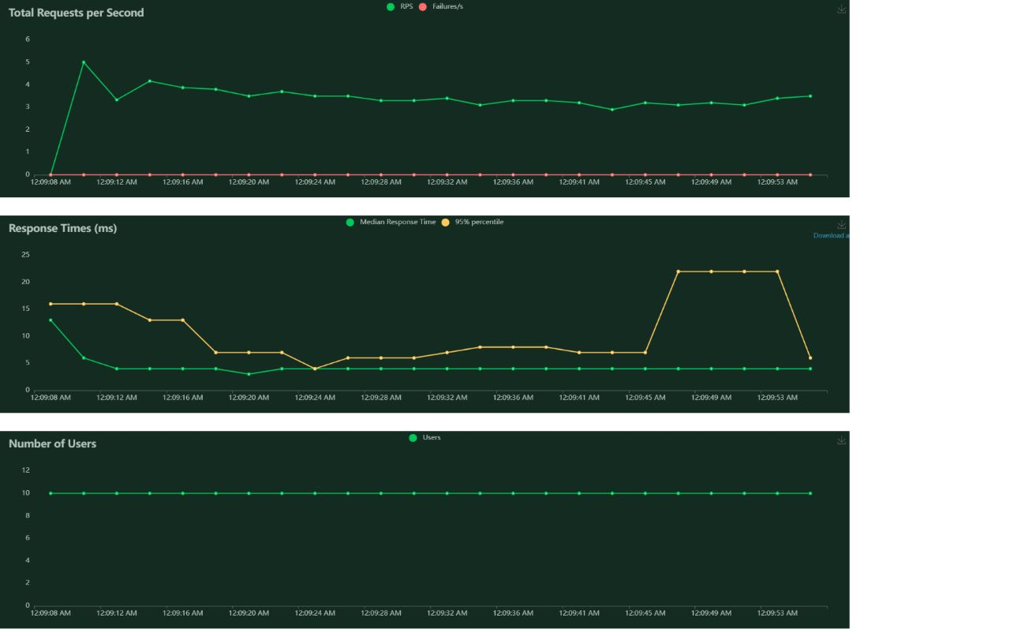

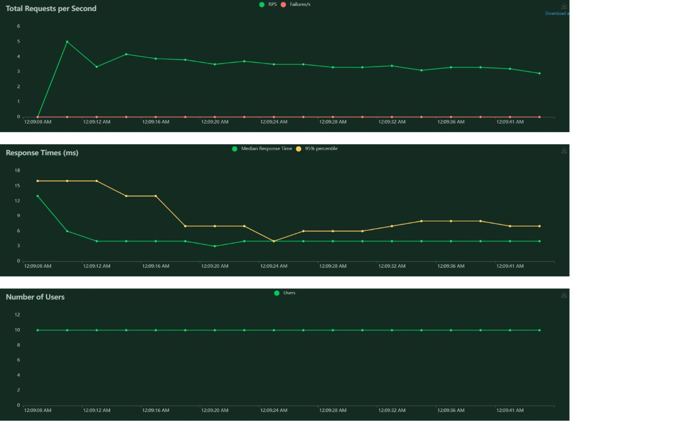

**9. RESULTS**

The Following passage which explains the end result of the overall development of the cloud application.

**9.1. Performance Metrics**

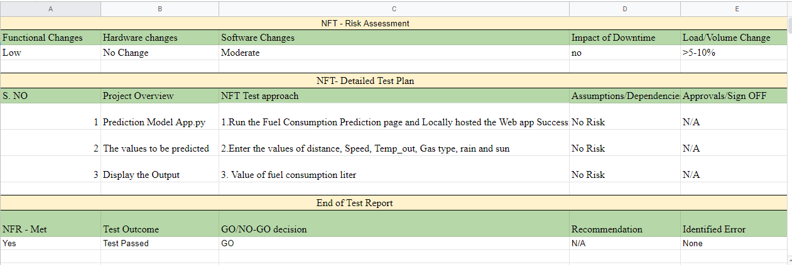

The accuracy of the technical side has accuracy 0.7309626842679302 rate of error where running model.

The three main metrics used to evaluate a classification model are accuracy, precision, and recall. Accuracy is defined as the percentage of correct predictions for the test data. It can be calculated easily by dividing the number of correct predictions by the number of total predictions.

Accuracy is the most intuitive performance measure and it is simply a ratio of correctly predicted observation to the total observations. One may think that, if we have high accuracy then our model is best

The Mean Squared Error measures the average of the errors squared. It basically calculates the difference between the estimated and the actual value, squares these results and then computes their average.

Because the errors are squared, MSE can only assume non-negative values. Due to the intrinsic randomness and noise associated with most processes, MSE is usually positive and not zero. Mean Squared Error: 1.2565262554606385

**10. ADVANTAGES & DISADVANTAGES**

**ADVANTAGES :**

* Diesels get great mileage. They typically deliver 25 to 30 percent better fuel economy than similarly performing gasoline engines.
* Diesel fuel is one of the most efficient and energy dense fuels available today. Because it contains more usable energy than gasoline, it delivers better fuel economy.
* Diesels have no spark plugs or distributors. Therefore, they never need ignition tune-ups.
* Diesel engines are built to withstand the rigors of higher compression. Consequently, they usually last much longer than gas-powered vehicles before they require major repairs.

**DISADVANTAGES :**

* Although diesel fuel is considered to be more efficient because it converts heat into energy rather than sending the heat out the tailpipe as gas-powered vehicles do, it doesn’t result in flashy high-speed performance.
* Diesels still need regular maintenance to keep them running. You have to change the oil and the air, oil, and fuel filters.
* Although diesel fuel used to be cheaper than gasoline, it now often costs the same amount or more.

**11. CONCLUSION**

This paper presented a machine learning model that can be conveniently developed for each heavy vehicle in a fleet. The model relies on seven predictors: number of stops, stop time, average moving speed, characteristic acceleration, aerodynamic speed squared, change in kinetic energy and change in potential energy. The last two predictors are introduced in this paper to help capture the average dynamic behavior of the vehicle. All of the predictors of the model are derived from vehicle speed and road grade. These variables are readily available from telematics devices that are becoming an integral part of connected vehicles.

Moreover, the predictors can be easily computed on-board from these two variables. The model predictors are aggregated over a fixed distance traveled instead of a fixed time interval. This mapping of the input space to the distance domain aligns with the domain of the target output, and produced a machine learning model for fuel consumption with an RMSE. Different model configurations with 1, 2, and 5 km window sizes were evaluated. The results show that the 1 km window has the highest accuracy.

**12. FUTURE SCOPE**

The current vehicles that are powered by gasoline pollute, but as technologies improve and the human way of life changes alternatively powered vehicles enter the automotive industry. These vehicles developed to achieve better gas mileage and to help slow the production of the gasses that cause Global Warming. The hybrid vehicle is one of the newest and most popular alternatively powered vehicles. Air pollution is the term used to describe any harmful gases in the air we breathe. Pollution can be emitted from natural sources such as volcanoes, but humans are responsible for much of the pollution in our atmosphere. The problem of air pollution was first recognized about 500 years ago when the burning of coal in cities was is one of the newest and most popular alternatively powered vehicles. The Industrial Revolution was a fast growth in industry that was based around the use of fossil fuels.

**13. APPENDIX**

**13.1. Source Codes**

**IBM Model training code:**

import os, types

import pandas as pd

from botocore.client import Config

import ibm_boto3

def __iter__(self): return 0

# @hidden_cell

# The following code accesses a file in your IBM Cloud Object Storage. It includes your credentials.

# You might want to remove those credentials before you share the notebook.

cos_client = ibm_boto3.client(service_name='s3',

    ibm_api_key_id='jueaPce6QMXYkjbx6RYyF1PoEmTqYPIEx5Obm7mc_HF9',

    ibm_auth_endpoint="https://iam.cloud.ibm.com/oidc/token",

    config=Config(signature_version='oauth'),

    endpoint_url='https://s3.private.us.cloud-object-storage.appdomain.cloud')

bucket = 'fuelconsumptionpredict-donotdelete-pr-ynmi9bkuwqjdf5'

object_key = 'measurements.csv'

body = cos_client.get_object(Bucket=bucket,Key=object_key)['Body']

# add missing __iter__ method, so pandas accepts body as file-like object

if not hasattr(body, "__iter__"): body.__iter__ = types.MethodType( __iter__, body )

data= pd.read_csv(body)

data.head()

import pandas as pd

import numpy as np

import os

from sklearn.model_selection import train_test_split

import matplotlib.pyplot as plt

import seaborn as sns

data.info()

dropped_data = data.drop(['refill liters','refill gas','specials'],axis = 1)

dropped_data.info()

dropped_data

def delete_comma_and_convert_float(df,column_name):

    index = df.columns.get_loc(column_name)

    for i in range(len(df[column_name])):

        value = df.iloc[i,index]

        value_list = value.split(',')

        if len(value_list) == 2:

            new_value = float(''.join(value_list)) / 10

            df.iloc[i,index] = new_value

        else :

            df.iloc[i,index] = float (value)

dropped_data['distance'] = dropped_data['distance'].astype(str)

delete_comma_and_convert_float(dropped_data, 'distance')

dropped_data['distance'] = dropped_data['distance'].astype(float)

dropped_data['consume'] = dropped_data['consume'].astype(str)

delete_comma_and_convert_float(dropped_data, 'consume')

dropped_data['consume'] = dropped_data['consume'].astype(float)

dropped_data['gas_type'] = dropped_data['gas_type'].map({'SP98': 1, 'E10': 0})

new_df = dropped_data[['distance','speed','temp_outside','gas_type','rain','sun','consume']]

sorted_df = new_df = new_df.sort_values('consume')

dataset_x = sorted_df.drop(['consume'],axis=1)

dataset_y = sorted_df.consume.values

sns.heatmap(new_df.corr(),cmap = 'BrBG', annot=True)

plt.subplot(161)

plt.scatter(dataset_x['distance'],dataset_y)

plt.subplot(162)

plt.scatter(dataset_x['speed'],dataset_y)

plt.subplot(163)

plt.scatter(dataset_x['temp_outside'],dataset_y)

plt.subplot(164)

plt.scatter(dataset_x['gas_type'],dataset_y)

plt.subplot(165)

plt.scatter(dataset_x['rain'],dataset_y)

plt.subplot(166)

plt.scatter(dataset_x['sun'],dataset_y)

plt.show()

x_train, x_test, y_train, y_test = train_test_split(dataset_x, dataset_y, test_size= 0.2, random_state= 42)

x_train.shape

x_test.shape

y_train.shape

y_test.shape

from sklearn.linear_model import LinearRegression

Model = LinearRegression()

Model.fit(x_train,y_train)

#To retrieve the intercept:

print(Model.intercept_)

#For retrieving the slope:

print(Model.coef_)

y_pred = Model.predict(x_test)

df = pd.DataFrame({'Actual': y_test.flatten(), 'Predicted': y_pred.flatten()})

df

df1 = df.head(25)

df1.plot(kind='bar',figsize=(16,10))

plt.grid(which='major', linestyle='-', linewidth='0.5', color='green')

plt.grid(which='minor', linestyle=':', linewidth='0.5', color='black')

plt.show()

from sklearn import metrics

print('Mean Absolute Error:', metrics.mean_absolute_error(y_test, y_pred))

print('Mean Squared Error:', metrics.mean_squared_error(y_test, y_pred))

print('Root Mean Squared Error:', np.sqrt(metrics.mean_squared_error(y_test, y_pred)))

!pip install  -U ibm-watson-machine-learning

from ibm_watson_machine_learning import APIClient

import json

wml_credentials = {

    "apikey":"l1fzrxmeL6hj7RAtabNLi7eiu0d83k8cthPzcjr21q52",

    "url":"https://us-south.ml.cloud.ibm.com"

}

wml_client = APIClient(wml_credentials)

wml_client.spaces.list()

SPACE_ID="5193e7e0-5829-4820-88db-85c86a30e655"

wml_client.set.default_space(SPACE_ID)

wml_client.software_specifications.list(100)

import sklearn

sklearn.__version__

MODEL_NAME = 'fuelConsumptionPredict'

DEPLOYMENT_NAME = 'Fuel Consumption Predict deployment'

DEMO_MODEL = Model

#set python Version

software_spec_uid = wml_client.software_specifications.get_id_by_name('runtime-22.1-py3.9')

#setup model meta

model_props = {

    wml_client.repository.ModelMetaNames.NAME: MODEL_NAME,

    wml_client.repository.ModelMetaNames.TYPE: 'scikit-learn_1.0',

    wml_client.repository.ModelMetaNames.SOFTWARE_SPEC_UID: software_spec_uid

}

#save model

model_details = wml_client.repository.store_model(

    model=DEMO_MODEL,

    meta_props=model_props,

    training_data = x_train,

    training_target=y_train

)

model_details

model_id = wml_client.repository.get_model_id(model_details)

model_id

#set meta

deployment_props = {

    wml_client.deployments.ConfigurationMetaNames.NAME: DEPLOYMENT_NAME,

    wml_client.deployments.ConfigurationMetaNames.ONLINE:{}

}

#deploy

deployment = wml_client.deployments.create(

    artifact_uid=model_id,

    meta_props=deployment_props

    )

**Building HTML Page Code:**

<!DOCTYPE html>

<html>

<head>

<title>Fuel Consumption Prediction using machine learning</title>

//<link rel="stylesheet" type="text/css" href="w">

<style>

  * {

    box-sizing: border-box;

  }

  body {

    font-family: 'Montserrat';

  }

  .header {

    top: 0;

    margin: 0px;

    left: 0px;

    right: 0px;

    position: fixed;

    background-color: black;

    color: whites;

    box-shadow: 0px 8px 4px lightgrey;

    overflow: hidden;

    padding-top: 15px;

    font-size: 2vw;

    width: 100%;

    text-align: left;

    padding-left: 100px;

    opacity:0.9;

  }

  .header_text{

    font-size: 2vw;

    text-align: center;

  }

  .content{

    margin-top: 100px;

  }

  .text{

    font-size:20px;

    margin-top:10px;

    text-align:center;

  }

  input[type=number], select{

    width:50%;

    padding: 12px 20px;

    margin: 8px 0;

    display: inline-block;

    border: 1px solid #ccc;

    border-radius: 4px;

    box-sizing: border-box;

  }

  input[type=submit] {

    width: 50%;

    background-color: #000000;

    color: white;

    padding: 14px 20px;

    margin: 8px 0;

    border: none;

    border-radius: 4px;

    cursor: pointer;

  }

  input[type=submit]: hover{

    background-color: #5d6568;

    color: #ffffff;

    border-color: black;

  }

  form{

    margin-top: 20px;

  }

  .result{

    color: black;

    margin-top:30px;

    margin-bottom: 20px;

    font-size: 25px

    color: red;

  }

</style>

</head>

<body align = center>

  <div class="header">

          <div>Fuel Consumption Prediction</div>

  </div>

  <div class = "content">

  <div class="header_text">Fuel Consumption Prediction</div>

  <div class= "text">Fill in and below details to predict the consumption on the gas type.</div>

  <form action="{{url_for('predict')}}" method="POST">

    <input type="number" step="any" id="distance" name="distance" placeholder="distance(km)" ><br>

    <input type="number" id="speed" name="speed" placeholder="speed(km/hr)"><br><br>

    <input type="number" id="tem_outside" name="tem_outside" placeholder="temp_outside(°C)"><br>

    <input type="number" id="gas_type" name="gas_type" placeholder="gas_type"><br><br>

    <input type="number" id="rain" name="rain" placeholder="rain"><br>

    <input type="number" id="sun" name="sun" placeholder="sun"><br><br>

    <input type="submit" value="Submit">

  </form>

</body>

</html>

**Building Server Side Script Code:**

import flask

import joblib

import requests

from flask import render_template, request

from flask_cors import CORS

# NOTE: you must manually set API_KEY below using information retrieved from your IBM Cloud account.

API_KEY = "l1fzrxmeL6hj7RAtabNLi7eiu0d83k8cthPzcjr21q52"

token_response = requests.post('https://iam.cloud.ibm.com/identity/token', data={"apikey": API_KEY, "grant_type": 'urn:ibm:params:oauth:grant-type:apikey'})

mltoken = token_response.json()["access_token"]

header = {'Content-Type': 'application/json', 'Authorization': 'Bearer ' + mltoken}

app = flask.Flask(__name__, static_url_path='')

CORS(app)

@app.route('/', methods=['GET'])

def sendHomePage():

    return render_template("prediction.html")

@app.route('/y_predict', methods=['POST'])

def y_predict():

    distance = float(request.form['distance'])

    speed = int(request.form['speed'])

    tem_outside = int(request.form['tem_outside'])

    gas_type = int(request.form['gas_type'])

    rain = int(request.form['rain'])

    sun = int(request.form['sun'])

    X  = [[distance, speed, tem_outside,gas_type,rain,sun]]

    payload_scoring = {"input_data": [{"field": [['distance', 'speed', 'tem_outside', 'gas_type','rain','sun']], "values": X}]}

    response_scoring = requests.post('https://us-south.ml.cloud.ibm.com/ml/v4/deployments/50f7f5a7-b0e4-458f-9f9f-6eb5edb9936f/predictions?version=2022-11-11', json=payload_scoring,headers={'Authorization': 'Bearer ' + mltoken})

    print(response_scoring)

    predictions = response_scoring.json()

    predict = predictions['predictions'][0]['values'][0][0]

    return render_template("prediction.html",prediction_text=predict)

if __name__ == '__main__':

    app.run()

**Locust-Testing coding:**

from locust import HttpUser, between, task

class WebsiteUser(HttpUser):

wait_time = between(5, 15)

host = "https://google.com"

@task

def index(self):

self.client.get("/")

**13.2. GITHUB AND PROJECT DEMO LINK:**

**1)Github link :** [**https://github.com/IBM-EPBL/IBM-Project-43937-1660720717**](https://github.com/IBM-EPBL/IBM-Project-43937-1660720717)

**2)Project Demo Link:** [**https://youtu.be/Nhj3JYSA6Hg**](https://youtu.be/Nhj3JYSA6Hg)